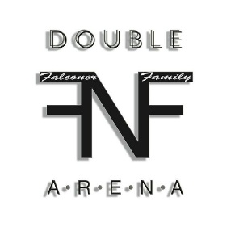
NBHA MN District 06 ~ Double F Arena: October 14 , 2018 ~ 35736 Hinckley Rd, Hinckley, MN
UBRA & P.E.W.C. Sanctioned

Name: ____________________________________________________________ Phone: __________________________ NBHA District: _______________

Address: ______________________________________________________________________________________ UBRA Number: ______________

HORSES NAME | Poles 2D  $10 | PeeWee  $5 | NBHA Open  $25 | Youth  $15 | Youth  Carry over ? | Senior  $15 | Senior Carry Over ? | UBRA Open  $20 | UBRA Open Carry Over? | Total

~ $3.00 NBHA Fee is included in the NBHA Classes Entry Fee
~ Carry over option is available to youth, senior, and 2nd open
~ Horse must start pattern within 3 minutes of being called or disqualification will be given
Warm Up $10 _______
By entering this event I agree to become familiar with and abide by the rules of this event. NBHA, MN 06, Sponsors & KC Arena are not responsible for any, injury, accidents, loss or theft that may occur to You, Your horse or Your Property while attending this event either as a spectator or contestant. We DO NOT have Emergency Medical Technicians (EMTs) on site during this event. NBHA MN 06 decisions are to be final.

____________________________________________________
Signature (18 or under parent or legal guardian must sign) Date

Exhibitions $4 or 3/$10 _______
Pole Exhibitions $4 or 3/$10 _______
Class total _______
Office Fee (not for Peewee) __$10_
GRAND TOTAL _______

