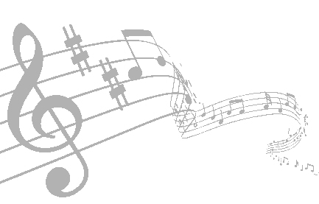
June 14-16, 2019

$5,000 Added Hosted By NBHA MN06
Double F Arena
35736 Hinckley Rd
Hinckley, MN 55037
Rockin’ Round the Clock

Name:____________________________________________ Phone: __________________________
NBHA: YES NO
PEWC: YES NO
BBR: YES NO
WRPA#: _______
Address: __________________________________________ City:_____________________________
Zip:____________________ Email:______________________________________________________
Friday: Circle CO for Carry over |  |  | 18 and under | 50+
NAME OF HORSE | Poles 2D | Open 4D | Youth 4D | Senior 4D | 2nd Open 4D | Total
 | $10 | $30 | $12 CO | $12 CO | $15 CO | $
 | $10 | $30 | $12 CO | $12 CO | $15 CO | $
 | $10 | $30 | $12 CO | $12 CO | $15 CO | $

Saturday: Circle CO for Carry over |  |  |  | 18 and under | 50+
 | Poles 2D |  | Open 4D | Youth 4D | Senior 4D | 2nd Open 4D | Total
NAME OF HORSE |  |  | $2,000+ |  |  | $500+
 |  | $10 | $45 | $15 CO | $15 CO | $25 CO | $
 |  | $10 | $45 | $15 CO | $15 CO | $25 CO | $
 |  | $10 | $45 | $15 CO | $15 CO | $25 CO | $

Sunday: Circle CO for Carry over |  |  |  |  |  | 18 and under | 50+
 |  | Poles 2D |  | Open 4D |  | Youth 4D | Senior 4D | 2nd Open 4D |  | Total
NAME OF HORSE |  |  |  | $2,000+ |  |  |  | $500+
 |  |  | $10 | $45 |  | $15 CO | $15 CO | $25 CO |  | $
 |  |  | $10 | $45 |  | $15 CO | $15 CO | $25 CO |  | $
 |  |  | $10 | $45 |  | $15 CO | $15 CO | $25 CO |  | $
Peewee 10&under | Horse:___________________ |  |  |  | Friday $5 Sat $5 Sun $5 |  |  |  | Total $____

~ $3.00 NBHA Fee is included in the NBHA Classes Entry Fee
Total Entries $ ______
#_____Stalls @ 63 each includes 1 bag of shaving $ ______
# ______ Shavings $8 each $ ______
Jump out $5/day or $15 for weekend $ ______
$55 Electric Camping (2 nights) $ ______
Tshirt ($20) Circle: S M L XL XXL $_______
Late Fee (if post marked after June 1^{st)} $10 $ ______
$10 Office fee per day or $20/Weekend $ ______
WEEKEND TOTAL $ ______
~ Carry over option is available to youth, senior, and 2nd open
~ Horse must start pattern within 3 minutes of being called or
disqualification will be given
By entering this event I agree to become familiar with and abide by the rules of this event. NBHA, MN 06, Sponsors & KC Arena are not responsible for any, injury, accidents, loss or theft that may occur to You, Your horse or Your Property while attending this event either as a spectator or contestant. We DO NOT have Emergency Medical Technicians (EMTs) on site during this event. NBHA MN 06 decisions are to be final.

____________________________________________________
Signature (18 or under parent or legal guardian must sign) Date

Please make out and mail checks to: NBHA MN06
2162 Thell Rd, Wrenshall, MN 55797
Pre Enter by June 1st to avoid $10 Late fee

